PROJECT DESIGN PHASE

Solution Architecture
Date | 29 September 2026 | Team ID: [Enter Team ID]
Project Name: AI-powered FAQ and Customer Support Automation (AnswerBot)

Architecture Overview
The application uses a layered, headless backend architecture. Requests enter through Express routes, pass authentication/validation middleware, execute controller and service logic, and persist data through Mongoose to MongoDB. AI generation is delegated to a Gemini service.
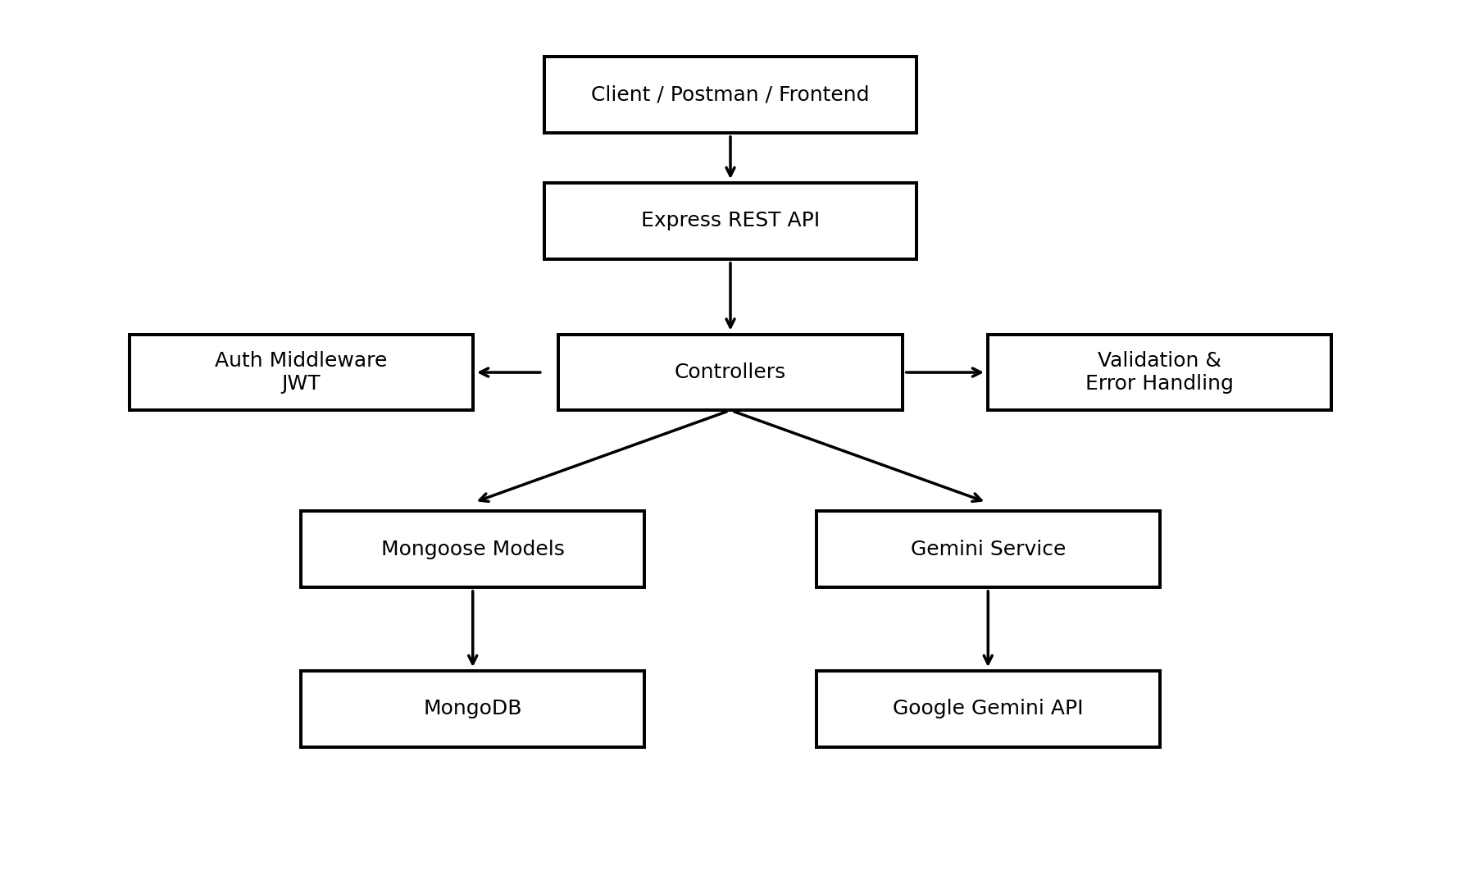

Component Responsibilities
Component | Responsibility
Client / API Consumer | Postman, Thunder Client, frontend application or chatbot sends HTTP requests and consumes JSON responses.
Express Routes | Map HTTP methods and paths to controller functions.
Auth Middleware | Extracts and validates JWT tokens for protected routes.
Controllers | Apply request logic and coordinate models/services.
Mongoose Models | Define User and FAQ schemas, validation and MongoDB interaction.
MongoDB | Stores user accounts and FAQ documents.
Gemini Service | Sends prompts to Google Gemini and returns generated FAQ content.
Error Middleware | Returns consistent, sanitized API errors.

Security Flow
- User registers; password is hashed before persistence.
- User logs in with email and password.
- Server issues a signed JWT.
- Client sends the token as a Bearer token for protected routes.
- Middleware validates the token and attaches user context before FAQ modification.

